**Fanka Shundovska**

**POSTMAN Homework 2**

* Create a new workspace called HomeworkWorkSpace.

- We will use the **petstore.swagger** **/user** section, and create collection, environment and global variables for the following requests:

* POST/user

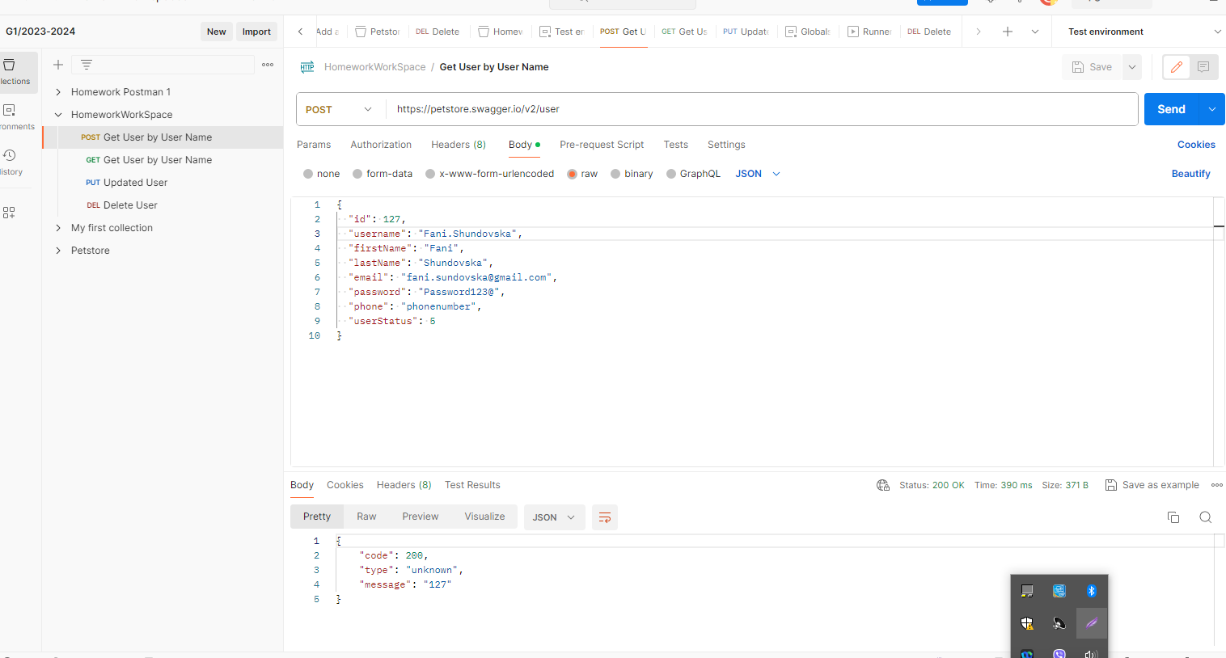

* GET/user/fani.sundovska,

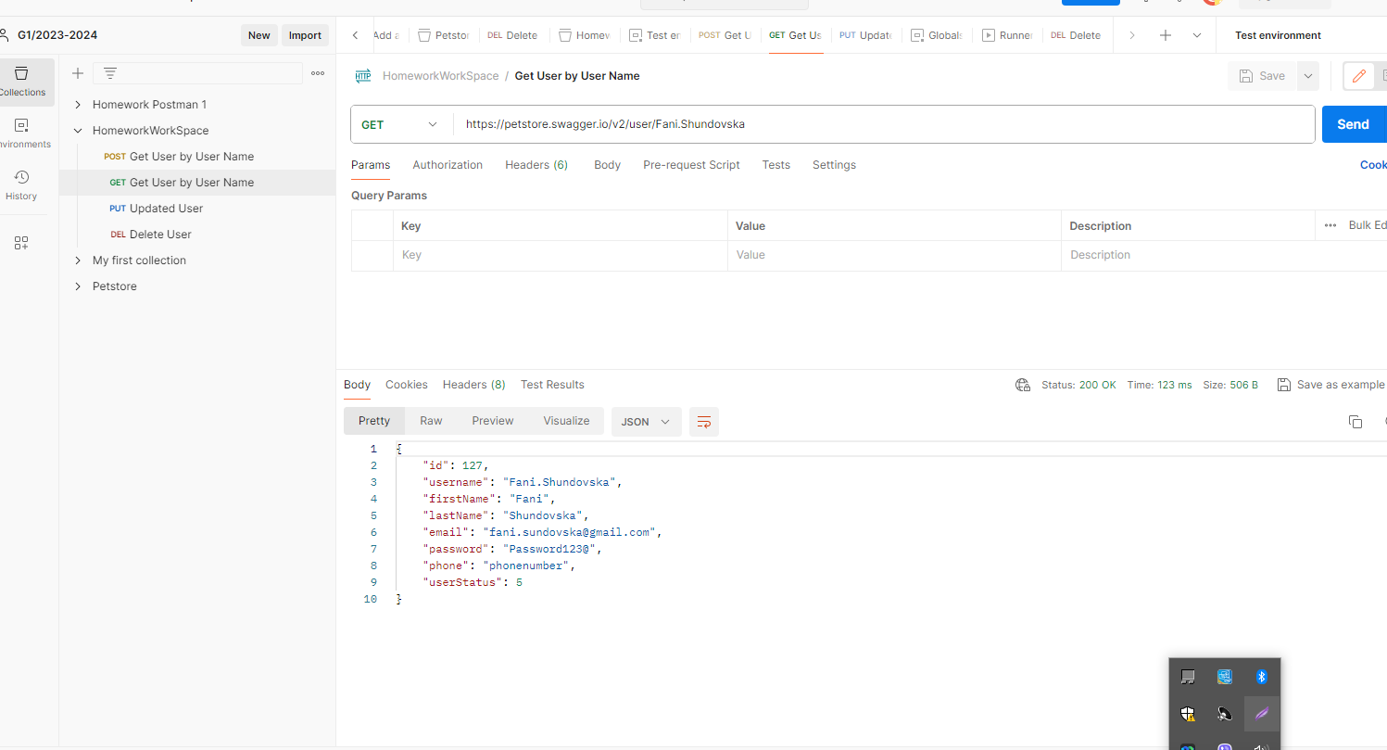

* PUT/user/fani.sundovska,

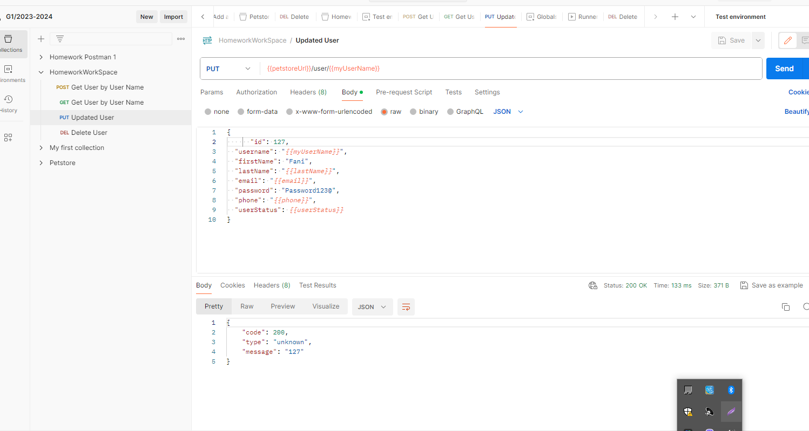

* DELETE/user/fani.sundovska,

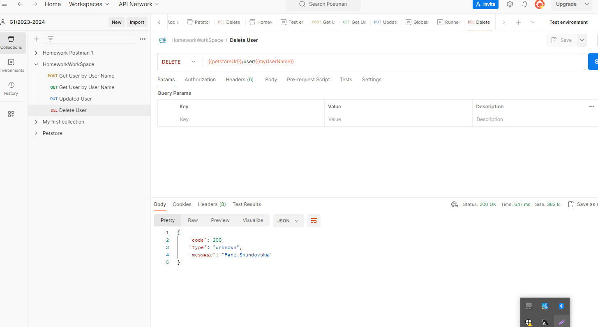

- The task will be to put the following properties in a variables and execute the requests:

* username: Collection Variable.
* lastName: Collection Variable

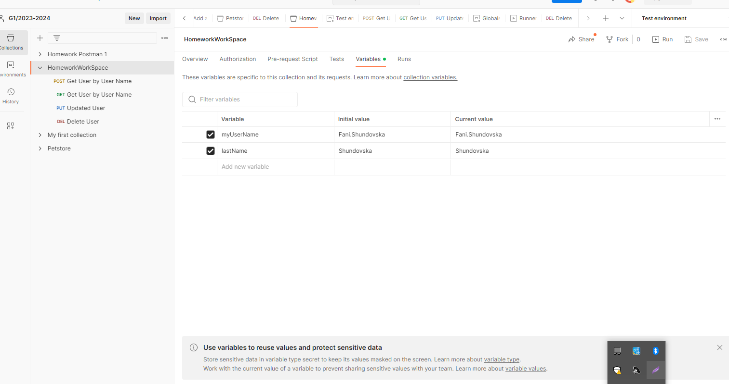

* petstoreUrl: Environment Variable.
* Phone: Environment Variable

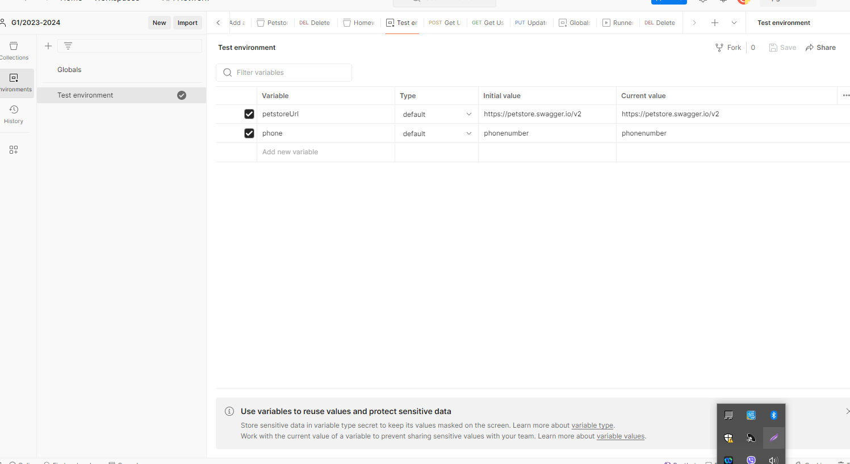

* Email: Global variable to **generate random** e-mail address. (Hint: We need a random global variable that Postman offers)
* UserStatus: Global variable.

